Trimpot / Potentiometer Interfacing to Arduino:
Introduction:
Trimpot
Trimpots are used for getting variable / adjustable user inputs. Common example of a trimpot is the volume knob of your stereo player, Tuning knob of the radio, etc.
A Trimpot aka variable resistor has three pins and an adjustment screw. A Trimpot acts as a potential divider and gives an output voltage on the 2nd pin. This output voltage is in-between the voltages supplied to the 1st and 3rd pins. The output voltage can be varied by adjusting the screw. The 1st and 3rd pins are connected to SUPPLY / GROUND and the middle pin is connected to Analog Input 0 on the arduino using a wire.
Requirment:
- Trimpot
- Breadboard
- Arduino Board

Hardware configuration:

See the pin mapping of Trimpot:

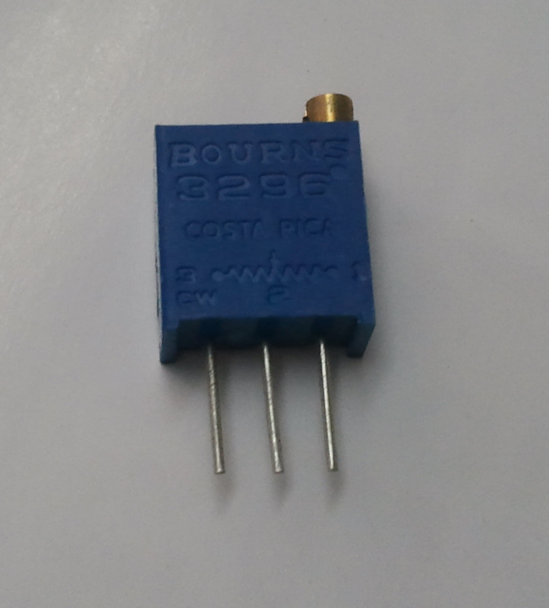

Step1:Place the trimpot as breadboard.

Step2: Connect a wire between pin 1 of the trimpot and the '+'ve terminal

Step3: Connect a wire between pin 3 of the trimpot and the '-'ve terminal

Step4: Connect a wire between pin 2 of the trimpot and the Analog In 0 of the Arduino

Step5: Connect a wire between pin 2 of the trimpot and the Analog In 0 of the Arduino as shown below.

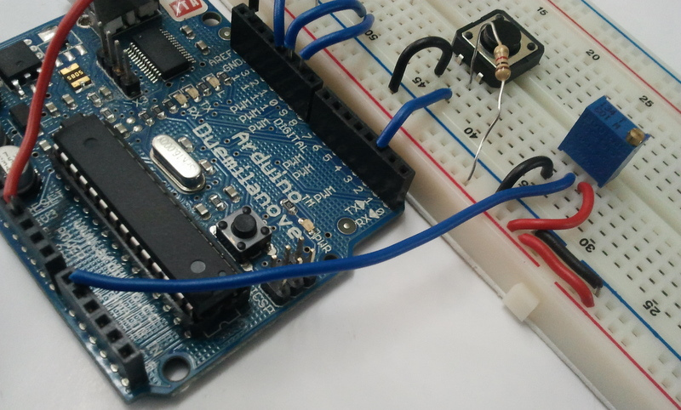

Heres the final setup and the output!:

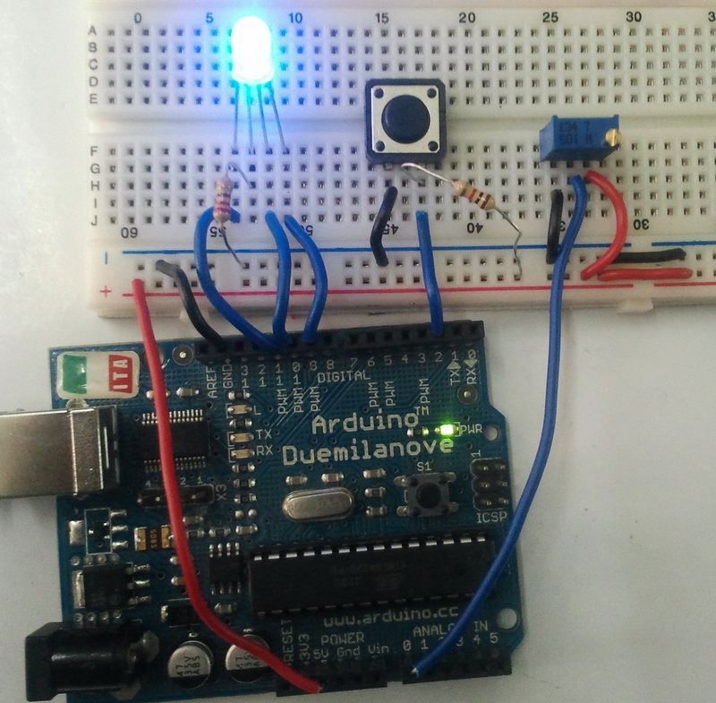

Programing:(source code)

/*
Pressing the Button changes the current active color of the RGB LED and varying the trimpot changes the intensity of the color
*/

int intensity = 0, pin = 9;

void setup() {
pinMode(2,INPUT);
Serial.begin(9600);
}

void loop() {
if(digitalRead(2)==0) // Switch being pressed
{
if(pin<11)
pin++;
else
pin=9;
analogWrite(9,0);
analogWrite(10,0);
analogWrite(11,0);
while(digitalRead(2)==0);
delay(100);
}
intensity = analogRead(0)/4; // Scaling the input resolution to match with our output resolution.
analogWrite(pin,intensity);
Serial.print(pin);
Serial.print(" ");
Serial.println(intensity);
}
Installation:
The source code copy to the skeches of arduino and compile (there is verify option) as shown given below.
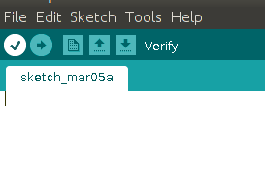

And then uploding the source code.(there is uploding option) to the Arduino board.(software) as shown given below.
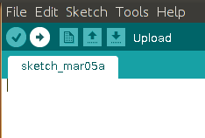

Troubleshooting:
FAQ:
Maintainers:
Duryodhan Aldar (durva.ges@gmail.com)

References: http://quickstartkitforarduino.blogspot.in/

